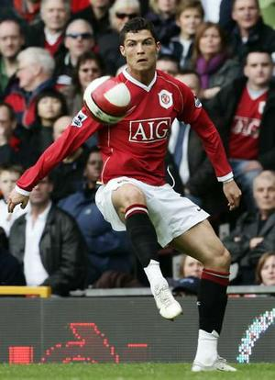
League Results

With just about all the league games completed now, the winners and runners-up in each division are pretty clear:

Under 10s

Winners: St John’s
Runners-up: Thorpe Salvation Army
The first season of Under 10s saw St John’s end up on top. Second place was clinched by Thorpe in their last game against the champions. Special mention to Cringleford, who only missed second place on goal difference.

Under 12s

Winners: St Peter’s Easton
Runners-up: St John’s
St Peter’s and St John’s were running pretty close all season but St Peter’s finally got the edge.

Under 14s

Winners: Surrey Chapel
Runners-up: King’s Community Youth
Surrey Chapel took first place quite a few weeks ago edging away from the rest. Kings finally secured second place in their final match.

Under 16s

Winners: St John’s
Runners-up: St Catherine’s or Brooke Adventurers
There are still a number of games to play in this league, and Brooke Adventurers still have a chance of overtaking St Catherine’s to capture second place. An interesting end to the season!

Men

Winners: UEA Christian Union
Runners-up: Surrey Chapel
Last year’s competition saw UEA up against Mount Zion for the title – with Mount Zion coming out on top by means of scoring just a few extra goals. This year, there were still 5 teams in with a chance of victory with a month to go, making this the most open contest in years. But, UEA managed to hold their nerve and wrapped up the championship with a game to spare.

Congratulations to all this season’s winners!

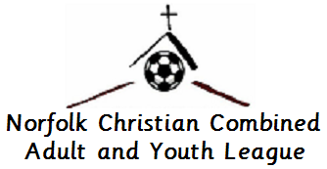

Cup Finals Programme 2007

Men’s Shield and Cup Competitions

St. Faith’s Centre
5th May
Wroxham Road Shield 10:30 a.m.
Bishop’s Cup 1.30 p.m.
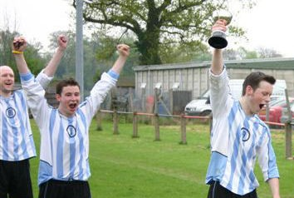
Youth Cup Competitions
Thorpe St. Andrew School
12th May, 9 a.m.

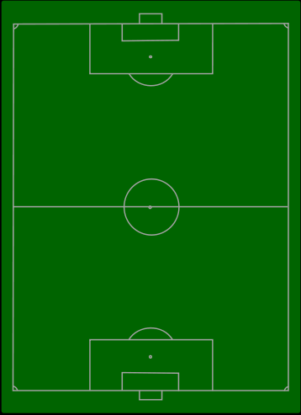
Welcome to the first cup finals of the
Norfolk Christian Combined Adult and Youth League!

"Whatever you do, work at it with all your heart, as working for the Lord"
Colossians 3:23

The Norfolk Christian Football League and the Norfolk Christian Youth League have enjoyed separate cup finals in the past; we look forward to the first finals of the amalgamated league doing justice to the great football that has been played throughout the rest of the season.

As a Management Committee, we have tried to run the league in a way that brings honour to Jesus, and we know that many managers and players work to the same goal. Without our Christian faith, the league would simply not exist. The league’s central purpose is to reach team-mates, colleagues and young people for Christ through an example set in playing and administering football. We hope we have done that.

Acknowledgements
- The NCCAYL committee are extremely grateful to the referees and assistants for giving up their time to officiate these matches.
- Appreciation to St Faith’s Centre for allowing us to use their premises for the Men’s Shield and Cup Finals
- Thanks are due also to Thorpe St Andrew School for the use of their new 3G Astroturf Pitches for the Youth Finals
- The Youth League 5-a-side tournament is planned for Saturday 9 June at Heartsease Park. Club secretaries should have details and entry forms.
- It is hoped the first of an annual Men’s 5-a-side tournament can be held on 16 June at the Towers Field. This will be in memory of John Sewell, who graced the youth and men’s leagues with his skills, but tragically died earlier this season. Please contact Mike Culwick if you are interested in entering or would like more details.

Full details of all the NCCAYL results and fixtures can be found on our web site http://www.ncyl.org.uk.
Bishop Maurice Wood Cup
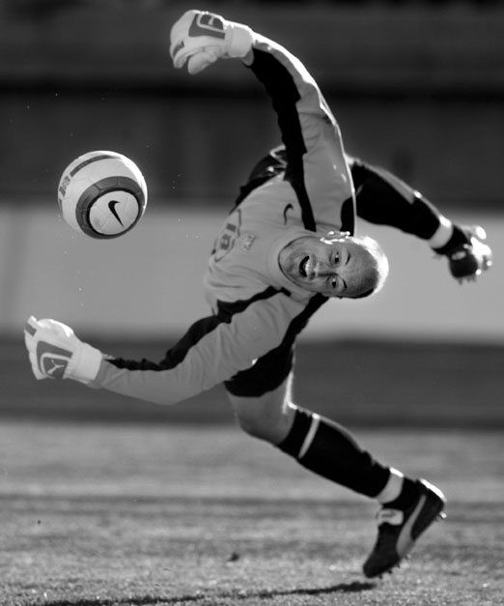
The main cup competition of the Men’s league is named after the Bishop of Norwich who presented the first trophy. This year’s final is being played at the St. Faith’s Centre in Horsham St. Faith for the first time; early finals were played at Carrow Road but this has not been possible in recent years.

Kings Community Church | v | Norwich Central Baptist Church
((from) |  | (from)
Chris Scott (GK) |  | Adam Hubbard
Mark Bullen (C) |  | Daniel Brocklehurst
Scott Winton |  | Craig Boyle-Smith
Paul Winton |  | Steve Taylor
Adam Mason |  | Peter Morgan
Ali Colman |  | Jason Hubbard
Chris Baikie |  | Matthew Price
Neil Bajomee |  | Ian Garrod
Allan Willrich |  | Chris Morgan
Danny Winton |  | Kevin Finch
Ciaran McClellan |  | Jamie Middleton
Colm McKeown |  | Mark Varley
Dan Stagg |  | Mark Waters
Ian Kettle |  | Matt Bolt
Dainer Lowthorpe
Deon Ruiters |  | John Habershon
 |  | Mark Fairweather-Tall
 |  | Matthew Varley
 |  | Matt Seager
 |  | Phil Meier
Coach: Dan Stagg |  | Coach: Mark Waters

Referee: Pete Loughborough
Assistants: Chris Allen, Chris Cate
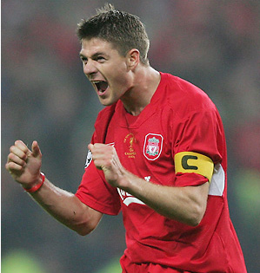
Wroxham Road Shield

This is the Christian League equivalent of the FA Trophy. It was instigated when the league boasted more than twice as many clubs as currently, and gave the opportunity for the lower-ranked teams to win some silverware. It was renamed last season, along with the purchase of a new trophy, in memory of all clubs – and the successful Wroxham Road team in particular – who have “retired” from the league over the years.

Surrey Chapel | v | Proclaimers
((from) |  | (from)
Blaine Lowthorpe (GK) |  | Ash Cotton
Gary Ryan |  | Dave Richmond
Kev Brown |  | Olly Kiff (C)
Lee Powley |  | Jon Salmon
Tim Drew |  | Ben Matthews
Troy Lowthorpe |  | Matt Wicks
Nat Bash |  | Dave Middleton
Sam Loaker |  | Mark Hodder
Dan Arden |  | Bendes
Billy Ledain |  | James Bailey
Justin Womack |  | Dan Jacobs
Keith Wilson |  | Dave Reynolds
Ben Aldridge |  | Ian Currie
Frank Nantongwe |  | James Patcher
Gaius Phillingham |  | Richard Jordan
 |  | Joel Fiddy
Coach: Jon Chaney |  | Coach: Olly Kiff

Referee: Malcolm Daynes
Assistants: Brendan Burke, Andy Starkings
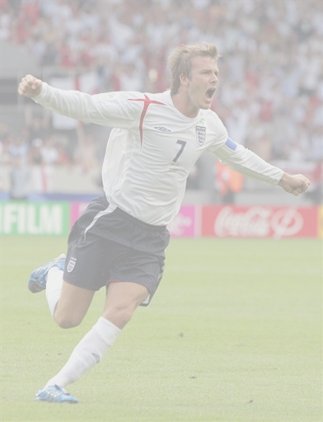
Under 12s

The cup started with two mini-leagues, with the winners and runners-up progressing to the semi-finals.

Group A | P | W | D | L | GD | Pts |  | Group B | P | W | D | L | GD | Pts
St Johns | 2 | 2 | 0 | 0 | 7 | 6 |  | Thorpe Salv. Army | 2 | 1 | 1 | 0 | 1 | 4
St Peters Easton | 2 | 1 | 0 | 1 | -1 | 3 |  | Holy Trinity | 2 | 0 | 2 | 0 | 0 | 2
Surrey Chapel | 2 | 0 | 0 | 2 | -6 | 0 |  | St Peters & St Pauls | 2 | 0 | 1 | 1 | -1 | 1

St. Johns | v | St. Peters Easton
((from) |  | (from)
Joshua Hannan (GK) |  | Jordan Baker
Klein Kwok |  | Joshua Newton
Scott Clarke |  | Matthew Rose
Jonathan Child |  | Hayden Rutherford (C)
Hugo Gilligan |  | Joshua Lane
Joshua Taylor |  | Ben Perry
Phillip Barnes |  | William Earp (GK)
Elliot Scales |  | Euan Jacks
Calum Burke (C) |  | Joseph Brown
 |  | Raphael Barnet-Ward
 |  | Alex Middleton
Coach: Dominic Burke |  | Coach: Colin Fell

Referee: Simon Nobbs
Assistant: Simon Morley
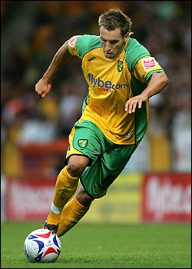
Under 14s

The cup started with two mini-leagues, with the winners and runners-up progressing to the semi-finals.

Group A | P | W | D | L | GD | Pts |  | Group B | P | W | D | L | GD | Pts
Kings | 3 | 2 | 1 | 0 | 4 | 7 |  | Surrey Chapel | 2 | 2 | 0 | 0 | 8 | 6
Meadow Way | 3 | 1 | 2 | 0 | 2 | 5 |  | St Peters Easton ‘A’ | 2 | 1 | 0 | 1 | 0 | 3
Brooke Advent’s | 3 | 1 | 1 | 1 | -2 | 4 |  | St Peters Easton ‘B’ | 2 | 0 | 0 | 2 | -8 | 0
Easton Eagles | 3 | 0 | 0 | 3 | -4 | 0

Meadow Way | v | St. Peters Easton ‘A’
((from) |  | (from)
Alex Clarke (GK) |  | Karl Yallop (GK)
Oscar Smith |  | Adam Bishop
Luke Smith |  | Callum Bradford
Ben Southgate |  | Richard Kennett
Matthew Lee (C) |  | Matthew Fell
Josh Petch |  | Matthew Stokes
Louis Nabarro |  | Kurtis LeFevre
Jordan Kareche |  | Ashley Granados
Tom Turner |  | Kristopher Dalgliesh
George Cuffley |  | Daniel Gilligan
Mark Bale |  | Arron Fernandez
Coach: Justin Fox |  | Coach: Tony Bishop

Referee: Pete Loughborough
Assistant: Chris Blower
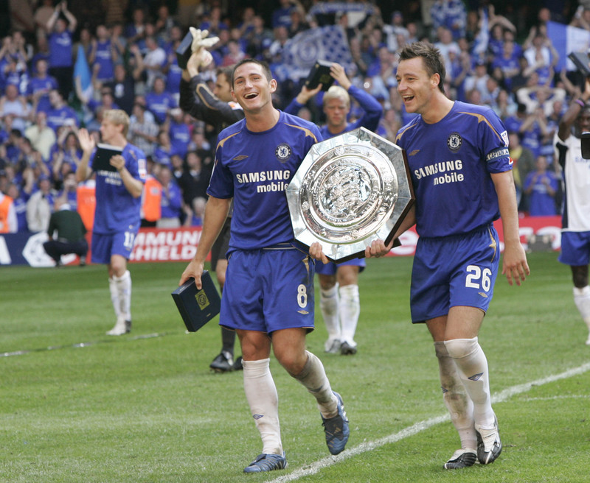
Under 16s

No mini-league start for the under 16s: instead, some teams received a bye into the quarters, leaving the rest to contest the 1st round.

Broadland Lads | v | St. Catherines
((from) |  | (from)
Tony Thrussel (GK) |  | Jack Allen (GK)
Daniel Chaney |  | Chris Bazely
Kristian Nelson |  | Mark Price
Michael Somerfield |  | David Hammond (C)
Aaron Clements |  | David Abel
Shane Gold |  | Jay Thompson
Jack Stuttle (C) |  | Jordan Butterfant
Lee Daniels |  | Chris Johnson
Jamie Curtis |  | Robert Price
Jonny Billings
Mitch Bruce-Smith
Coach: Adrian Shipley |  | Coach: Scott Marrison

Referee: Tim Stapleford
Assistant: Jim Green

